Purpose

This document provides guidance for the considerations in the review of cannabis related studies. In particular, what are the submission requirements for studies involving the use of cannabidiol (CBD).

Background

Cannabis is a genus of flowering plant in the family cannabaceae. Cannabis contains a variety of compounds (cannabinoids) which are ligands (binding agents) for cannabinoid receptors in the body. Early research into medicinal cannabis involved synthetic cannabinoid products including dronabinol and nabilone, whilst more recent studies have tended to use whole-plant extracts. Botanical marijuana contains many cannabinoids; the best known of which are delta-9 tetrahydrocannabinol (THC), cannabidiol (CBD) and cannabinol (CBN). THC is the main psychoactive compound in cannabis. CBD is not psychoactive, however both products have effects on the body and have side effects. While there is a long history of use, clinical data is still required to support the studies.
There have been a variety of plant-derived CBD products, CBD products synthetically produced in the lab, as well as new cannabinoid structures that are developed in the lab that do not occur naturally, for medical use. The use of cannabis products derived from plants may involve exposure to a mixture of cannabinoids, potentially changing with different strains from crop to crop or with potential variability (of the same strain) between crops.
The effects of cannabis within the boundaries of normal cannabinoid composition limits (those typically found in the cannabis plant) are reasonably well established. However, when the cannabinoid ratios/composition start falling outside of those normal limits there is increased uncertainty. Randomised controlled trials of cannabidiol (CBD) have shown adverse events including sedation, convulsions and gastrointestinal disturbance in some patients.
CBD and THC, being lipid plant extracts, require metabolism before excretion. Although there are standard pharmacokinetic (PK) and pharmacodynamic (PD) study data available, there are likely to be significant pharmacokinetic interactions, particularly with drugs that are metabolised by, or either inhibit or induce cytochrome P450 (CYP450) enzymes.
Given the long history of cannabis use, but limited clinical data, there are questions raised around the information required to support a study.
- Can literature based information be used versus preclinical data to support a study?
- What clinical information is required for consideration in the Protocol and Investigator’s Brochure (IB)?
- What information should be considered for the participants and therefore included in the Participant Information and Consent Form (PICF)?

Guidance
Clinical data and literature support:

The following flow chart outlines guidance for considering the appropriate support for an application:

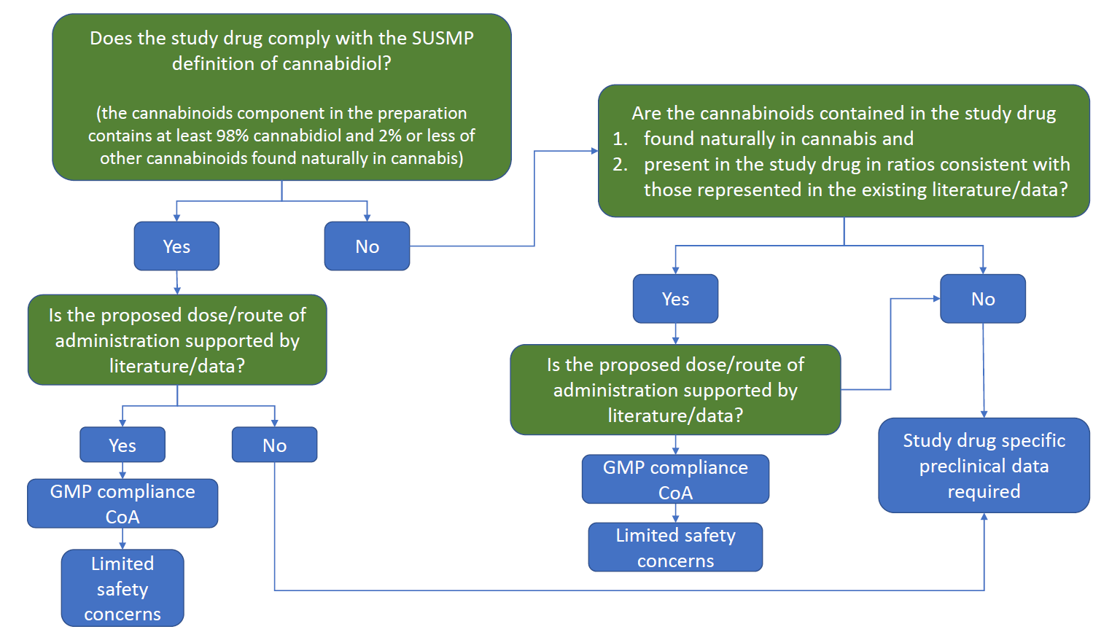

Where there are limited safety concerns, the Committee may consider that detailed literature information can be used to support the study. Consideration should also be given for each study as to whether the literature based evidence needs to be supplemented by additional safety data. In other cases as outlined in the flow chart, study specific preclinical data is required.

Study Documents Considerations:

- Protocol and Investigator’s Brochure (IB):
Dosing:
- Type of product, dosing regimine, dosing plan, route of administration, delivery device, first dose, individual patient variation, potential development of tolerance, outpatient dosing considerations.
Product detail:
- Manufacturing, product information, GMP compliance, source, extraction processes, preclinical data, stability data, supply arrangements, placebo and product colour, packaging and labelling requirements.

Treatment Plan:
- Treatment goals, starting and stopping rules, risk management processes, exit strategy.
Recruitment:
- Medical history, drug dependence, social history, physical investigations, cognitive examination.
Cautions:
- Concomitant medications
- Driving and machinery operation for THC products
- Relevant evidence for different conditions, doses, administration, products.

Adverse Events:
- Known adverse effects
- Recording adverse events
- Blood tests for monitoring
- Unusual events eg blood pressure and heart rate
- Safety data from plant based products is independent of synthetic product data.

Drug-Drug Interactions

- Drugs metabolised by CYP450
- Inhibition by drugs such as ketoconazole and clarithromycin increase concentrations of THC and CBD, while inducers such as rifampicin, carbamazepine, and St John’s Wort lower THC and CBD concentrations.
- Details of any co-administered medications, alcohol, tobacco and complementary medicines.

- PICF:

- Pregnancy: reproductive risks
- Driving/Operating Machinery for products containing THC
- Legal Issues for THC containing products related to drug testing
- Adverse event – Side effects, potential withdrawal symptoms, psychiatric adverse event management
- Defined mechanism for stepping down, stopping, or finishing the trial
- Ongoing trial/Post trial access if applicable.

References documents for guidance:
The following guidance documents are also noted for the reviewers as reference information:
- Botanical Drug Development Guidance for Industry Food and Drug Administration, Center for Drug Evaluation and Research (CDER) December 2016, Pharmaceutical Quality/CMC,Revision 1
- Cannabis and Cannabis-Derived Compounds: Quality Considerations for Clinical Research, Guidance for Industry, Food and Drug Administration, Center for Drug Evaluation and Research (CDER), July 2020, Pharmaceutical Quality/Chemistry, Manufacturing, and Controls (CMC)
- https://www.fda.gov/news-events/public-health-focus/fda-and-cannabis-research-and-drug-approval-process
- FDA Draft Guidance on Cannabidiol March 2021
- Guidance for the use of medicinal cannabis in Australia: Patient information, Version 1, December 2017
- ICH Q3B (R2) Impurities in new drug products - Scientific guideline

