Purpose
To outline the minimum requirements for insurance and indemnity as per the National Statement on Ethical Conduct in Human Research (2025) Chapter 5.1.

Definitions
Insurance: A policy taken out by an individual or individual organisation to cover their financial liabilities.
Indemnity: An indemnity is a promise by one party to another that it will cover a loss arising from an event that happens to the other party.
Clinical studies: research involving human participants for health-related interventions, including drugs, devices, biologicals, surgical techniques, diagnostic and screening tests, therapy, education and care.
Non-clinical studies: research involving social and behavioural sciences, and non-interventional/non-therapeutic research.

Guidance
Both Insurance and Indemnity are measures taken to guard against financial loss. Insurance is a policy taken out to cover the individual’s or institution’s risks or liabilities, and the insured pays a premium to transfer financial risk to another party. An indemnity is a contract between two parties in which one party agrees to cover a loss arising from an event that happens to the other party.
There must be insurance and indemnities in place to cover all studies. All studies must have a local sponsor and the local sponsor of a trial must be an Australian company or entity.
For clinical studies, the local sponsor endorses the CTN application. A local sponsor may be:
- An Australian Pharmaceutical company or an Australian subsidiary of an international pharmaceutical company.
- A Corporate Research Organisation (CRO) who acts as the local sponsor in the event the entity/company is not an Australian resident.
- An Australian collaborative research group.
- An investigator (usually an employee’s institution or no sponsorship is provided).
For non-clinical studies: sponsor responsibilities may be taken on by:
- The organisation submitting the application.
- The client of the organisation submitting the application (e.g., a government department).
For investigator initiated or non-sponsored studies, the investigator or their organisation takes the sponsor responsibilities and must submit the HREC Indemnity.

Insurance
Any person or organisation who has involvement in human research and are therefore exposed to potential liabilities should be covered by an adequate insurance policy. Adequate insurance is appropriate for both clinical trials and non-clinical trials.
Both the sponsor of the study and the Principal Investigator need to have adequate insurance cover before the trial can proceed. Co-investigators are also required to have personal insurance cover. The investigator’s professional indemnity cover must cover any gaps in any cover. Liabilities may arise from the initiation or sponsorship of the research. These liabilities may include the development of the research protocol or the conduct of the research.
It is a requirement of all Bellberry applications that the application form must outline which organisation is taking responsibility for insurance and indemnification. Before approving a study, Bellberry must be satisfied that arrangements exist to ensure adequate compensation to participants in the case of any injury suffered resulting from their participation in a study. The Principal Investigator acknowledges this in the declaration stage of their application.
Sponsors must have a certificate of insurance (certificate of currency). This is not required to be submitted to the HREC for review however may be requested during site monitoring/desktop auditing. A certificate of insurance at a minimum must:
- Name the Australian entity acting as the sponsor as a named insured under the insurance policy.
- Provide evidence that the insurance covers the conduct of the relevant study in Australia.
- Be an insurer with approval by the Australian Prudential Regulatory Authority or a foreign insurer with a minimum credit rating of Standard and Poor’s (or equivalent) of A- or higher.
- Provide evidence that the policy will be current throughout the entire period in which the study is conducted.
- Contain insurance coverage for a minimum amount of AUD$10 million for any one occurrence and in the annual aggregate. Each jurisdiction has different requirements, and the Sponsor and PI are responsible for ensuring the research has adequate coverage (National Statement 5.1.46-5.1.47). Bellberry reserve the right to review the insurance arrangements.
- Where the study concerns a registered product, products liability should be included.
- Ensure that care be taken with medical device studies as ongoing liability may be required to ensure cover is provided for the ongoing treatment risk.
- Cover no-fault liability. When there is no evidence of negligence or product cause for the injury, this recognises that were it not for the participants’ participation in the trial there would be no injury.

Indemnity
Sponsors must also have indemnities in place to cover the study. Indemnities are required for all studies, not just clinical studies. There are two types of indemnities;
- the Standard indemnity between the sponsor and the Principal Investigator/site, and
- the HREC indemnity between the sponsor and the HREC.
A Standard Indemnity is not required to be submitted to the HREC for review however may be requested during site monitoring/desktop auditing.
A HREC Indemnity must be provided and fully executed before an approval letter may be issued for an initial application or any study change requiring an updated indemnity. It is the responsibility of the sponsor, or the entity taking on the responsibilities of the sponsor, to provide the HREC indemnity to the HREC (National Statement 5.1.42 (e) and 5.1.46) and is recommended this be provided as early as possible in the study review process so as not to hold up any approval. Where an initial application has been recommended for approval and the Indemnity has not been provided within 6 months, the application may be administratively closed.
Please note, a HREC indemnity is not required for Investigator-led studies that are submitted under the New South Wales Early Phase Clinical Trial (EPCT) Framework. An indemnity is required for all non-NSW EPCT Investigator-led study submissions.

Indemnity Template and Content
Indemnities must be in a form no less favourable than the current Medicines Australia (MA) or the Medical Technology Association of Australia (MTAA) Form of Indemnity.
Bellberry has modelled a Non-Clinical HREC Indemnity (BA F15.1.4) on the Medicines Australia template. Parties utilising the Indemnity must note that the document is not a Medicines Australia approved standard template. The indemnity can also be used for social science studies.
Bellberry requests that the template is used relevant to the study type (Medicines Australia, Medical Technology Association of Australian or Bellberry Non-clinical) and that the template wording or paragraph numbering is not changed.
If the Sponsor or Indemnifying party requests changes to a template, Bellberry can consider amendments that are relevant to the research study, or an alternative can be provided. Where requested for consideration by Bellberry, please send a tracked version of the indemnity highlighting the proposed changes to bellberry@bellberry.com.au. Bellberry must view and agree to any changes to the standard clauses within the indemnity template agreement before execution. Once agreed upon, the sponsor can use this same form of indemnity with Bellberry for any future studies where the same conditions apply.
The HREC indemnity must name the local commercial Sponsor, ensuring the Sponsor is an Australian corporate entity. Please note that if a CRO or local entity is providing the indemnity, it is not acceptable for the indemnity to be from the CRO or local entity as an agent of the overseas company. The CRO or local entity must provide the indemnity in their own right.

Non-sponsored studies
Insurance and indemnities are required for non-sponsored studies. The HREC indemnity will be required to be provided by the entity that is taking on sponsor responsibilities in the same way it would for a sponsored study. In this instance, the investigator, the investigator’s employer or organisation conducting the study may confirm that they are taking on responsibility of the insurance and indemnity.
The Bellberry Director of Operations or CEO reserve the right to review the insurance and indemnity for any high-risk non-sponsored study. Bellberry may seek insurance advice before any granting any approvals.

Lower risk studies
Insurance and indemnities are required for lower risk studies, whether sponsored or non-sponsored. Where necessary, Bellberry may seek insurance advice before granting any approvals.

Study changes that require an updated indemnity:
- Change of local sponsor.
- Change of study title.
- Change of Principal Investigator.
- Submission of a new multi-centre site, or a separate indemnity can be provided for this site only.
Please note, an updated Indemnity is not required where there is a change to the sponsor’s name, address or a site’s name if the ABN remains the same.

Template
All placeholders in the HREC Indemnity must be completed as indicated:
To: Bellberry Limited
Level 1, 196 Greenhill Road, Eastwood, SA 5063
ABN: 16 109 019 730 ("the Indemnified Party")

From: Include the sponsors full name, address and ABN.
If it is an Investigator initiated or non-sponsored study, then the Principal Investigator or their Organisation would normally be the Indemnifying party. In this instance, their address and ABN should be provided in this section.
Re: Include the full title of the Protocol exactly as stated in the Protocol document and eProtocol application.
Paragraph 1:
- Replace the placeholder wording [{patients of [name of hospital(s), institution(s) or site(s)]} {non-patient volunteers}] with the description that relates to the participants of your study.
- Replace the placeholder wording [name of investigator(s)] with the name of the Principal Investigator.

Example 1: The ‘non-patient volunteer’ clause shown in the following example may be used when the study participants of a research institution would not be considered ‘patients’ of the organisation and instead are considered healthy volunteers.
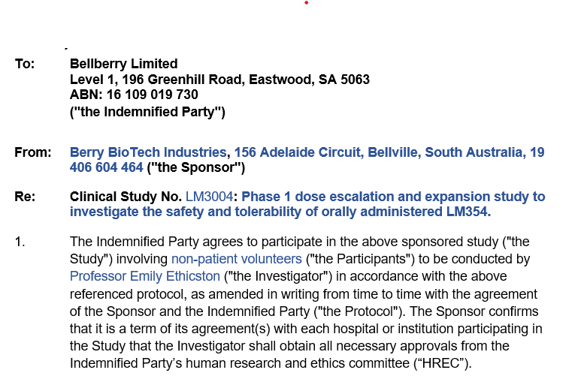

Example 2: A multicentre study listing its separate sites and the Principal Investigators responsible for oversight of those sites:
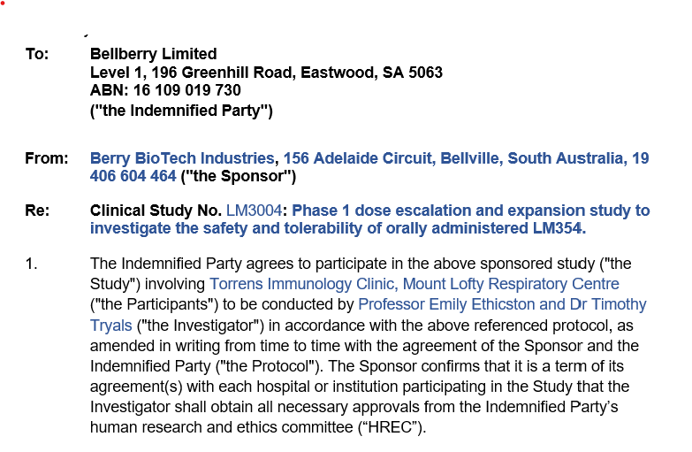

Indemnity Format
Bellberry can accept indemnities electronically via a verifiable online platform such as DocuSign or AdobeSign or a hard-copy version can be posted. Indemnities may be sent as a document attachment in an email for proofreading or advice however, are not accepted in this format as a final version for execution.
If sending electronically and the study is multi-centre, please only list the sites in the Indemnity that are ready to submit an application or will submit before the lead site application is ready for approval. This is to avoid potential delay in approval to the lead site application, as all sites and Principal Investigators listed in the indemnity must have submitted an application in eProtocol, in order for the Indemnity to be fully executed.
Please send electronic indemnities via an online platform to bellberry@bellberry.com.au. If your company requires the document to be emailed to an individual and not a generic mailbox, please send to lizdoolin@bellberry.com.au or jerneenwilliams@bellberry.com.au. Please ensure that bellberry@bellberry.com.au is included in the carbon copy (CC) field of the email. Please take note of any out of office replies that may delay execution of the document.
When preparing the document in the online platform such as DocuSign or AdobeSign, three fields must be included by the sender for the Bellberry Signatory to complete – Signature, Name and Position. Please select the option to make each of these fields editable as there are multiple people delegated responsibility to sign the document on behalf of Bellberry. Once received, Bellberry are unable to make any edits on behalf of the sender. As such, if the name is incorrect and not editable, the indemnity will need to be returned to be edited by the sender, e.g. if the signatory name is ‘Bellberry’. Please note, some platforms may have settings where details are auto-filled depending on the recipient, please check these carefully prior to sending.
The indemnity must be signed by the sponsor representative prior to sending the indemnity to Bellberry for signature.
Bellberry does not accept scanned copies of a HREC indemnity with either an electronic signature or wet ink signature. As the indemnity is a legal document, both parties must sign the original document. The signatures must be verifiable and as a scanned document will not have the electronic validation mark, it cannot be accepted and must be signed through the electronic platform used.
For necessary changes to electronic indemnities, the indemnity will be returned to the site/sponsor to be amended as Bellberry is unable to edit any electronic forms on behalf of the sender.
For necessary changes to paper copy Indemnities, Bellberry administration will strike out and initial these changes in wet-ink before executing the document. The fully executed Indemnity will be scanned and a copy attached to the eProtocol application(s). The original document will be returned to the sender by post.

References
National Statement on Ethical Conduct in Human Research (2025)
Medicines Australia (MA) Form of Indemnity
Medical Technology Association of Australian (MTAA) Form of Indemnity
BA F1.1.1 Submission Requirements Checklist
BA F15.1.2 MA Clinical HREC Indemnity 1 October 2012
BA F15.1.3 MTAA Device HREC Indemnity 10 April 2024
BA F15.1.4 Bellberry Non-Clinical HREC Indemnity

